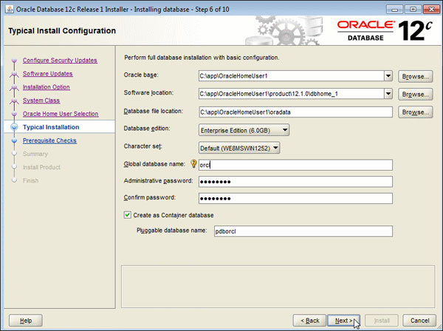

Change the default character set to AL32UTF8 and uncheck “Create as Container Database”